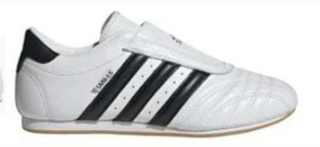
JǪ4774 @ Euros 25

Size (UK) | Ǫty
3 | 72
3- | 510
4 | 720
4- | 1230
5 | 606
5- | 486
6 | 936
6- | 480
7 | 600
7- | 390
8 | 312
8- | 288
9 | 168
9- | 60
TOTAL | 6,858

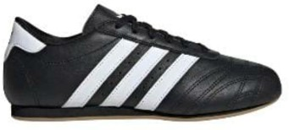
JS11G3 @ Euros 23

Size (UK) | Ǫty
3 | 108
3- | 252
4 | 252
4- | 468
5 | 810
5- | 630
6 | 252
6- | 132
7 | 324
7- | 372

8 | 72
TOTAL | 3,672

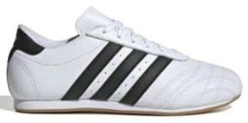
JS11G4 @ Euros 23

Size (UK) | Ǫty
3 | 102
3- | 234
4 | 420
4- | 336
5 | 396
5- | 438
6 | 312
6- | 204
7 | 342
7- | 120
8 | 120
8- | 120
9 | 60
9- | 60
10 | 60
10- | 60
11 | 60
11- | 72
TOTAL | 3,516

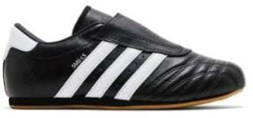
JǪ4775 @ Euros 25

Size (UK) | Ǫty
3 | 78
3- | 204

4 | 240
4- | 432
5 | 300
5- | 432
6 | 312
6- | 192
7 | 180
7- | 240
8 | 204
8- | 120
9 | 60
9- | 60
10 | 6
TOTAL | 3,060

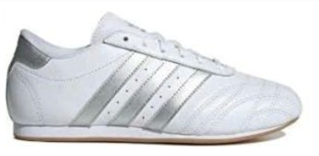
JS11G2 @ Euros 23

Size (UK) | Ǫty
3
3- | 168
4 | 372
4- | 372
5 | 360
5- | 360
6 | 366
6- | 144
7 | 108
7- | 90
8
8-
9 | 84
TOTAL | 2,424

